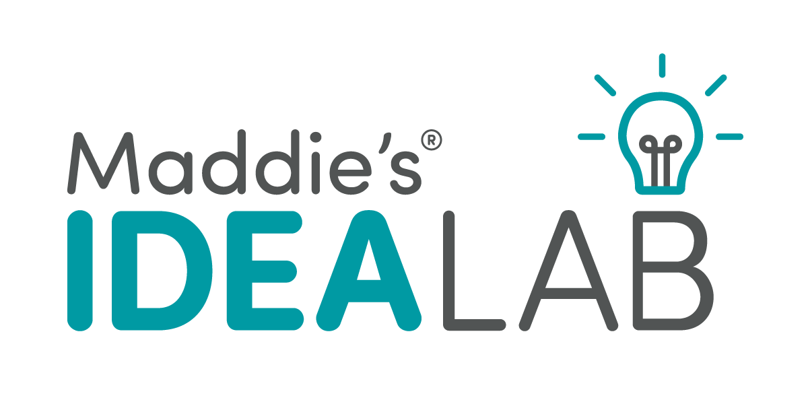
Pre-Application Inquiry Form

Maddie’s Fund® is offering research grants to Universities, Colleges and Shelters/Rescue Organizations that have innovative ideas they would like to evaluate. Maddie’s® Idea Lab grants allow you to either perform basic research or test an idea on a small scale (Phase 1). If your idea is successful, it may be eligible to proceed to larger scale phases of testing to demonstrate whether that idea is successful for different types of organizations in different geographic regions (Phases 2 – 4).

We encourage ideas that:
- have the potential to provide simple and inexpensive solutions to problems that some organizations find too costly or too difficult to treat.
- are easily replicable at other shelter and rescue organizations with varying resources.
- save lives and improve welfare of homeless pets.

Grant deadlines occur on a quarterly basis, in January, April, July and October. In general, Phase 1 and 2 grant applications are usually for up to $25,000, Phase 3 applications are for up to $150,000 and Phase 4 and Basic Research grants are considered on an individual basis.

Before submitting an application, please submit this Pre-Application Inquiry Form to research@maddiesfund.org.

Please provide the following information:

- First and Last Name, including any credentials (DVM, PhD, etc.): _________________________________________________________________________
- Job Title: __________________________________________________________________________
- Email address: _________________________________________________________________________
- Organization Name (can be a shelter/rescue organization or university/college): _________________________________________________________________________
- Website: __________________________________________________________________________

- Tell us about your idea in one page or less (shorter is better!) – what will you do and how will it advance lifesaving, leadership or the utilization of foster care?
- Do you need help identifying a research scientist or shelter/rescue organization to collaborate on this project?
  - __Yes
  - __No
    - Who will you be collaborating with? __________________________________________________________________
- How much do you expect this project to cost? _________________________________________________________________________

