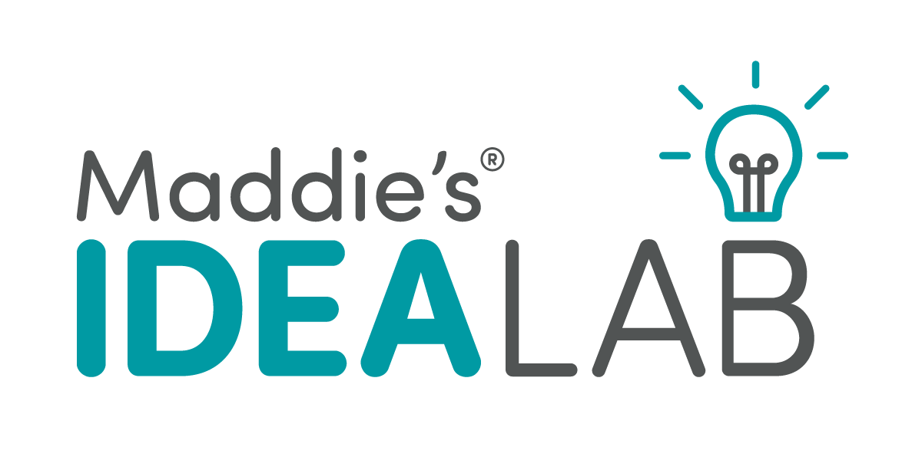
Shelter Application

Maddie’s Fund is offering research grants to Universities, Colleges and Shelters/Rescue Organizations that have innovative ideas they would like to evaluate. Maddie’s® Idea Lab grants allow you to either perform basic research or test an idea on a small scale (Phase 1). If your idea is successful, it may be eligible to proceed to larger scale phases of testing to demonstrate whether that idea is successful for different types of organizations in different geographic regions (Phases 2 – 4).

We encourage ideas that:
- have the potential to provide simple and inexpensive solutions to problems that some organizations find too costly or too difficult to treat.
- are easily replicable at other shelter and rescue organizations with varying resources.
- save lives and improve welfare of homeless pets.

Grant deadlines occur on a quarterly basis, in January, April, July and October. In general, Phase 1 and 2 grant applications are usually for up to $25,000, Phase 3 applications are for up to $150,000 and Phase 4 and Basic Research grants are considered on an individual basis.

You must submit the Maddie’s® Idea Lab – Pre-Application Inquiry Form and receive an invitation from Maddie’s Fund to submit this application.

Note: This application is for Shelters/Rescue Organizations that are the primary applicant and if approved, the organization who will be receiving the grant. If a different organization will be managing the funds from this grant, please complete the Maddie’s® Idea Lab – University Application.

Please provide the following information:

- Organization Information
  - Name of Organization: _____________________________________________________________________________
  - Head of Organization (who will sign the grant confirmation letter if this grant is awarded):
    - Name: _____________________________________________________________________
    - Title:
___________________________________________________________________________
    - Phone: ___________________________________________________________________________
    - Email: ___________________________________________________________________________
  - Organization Address:
    - Street: __________________________________________________________________________
    - City, State, Zip: __________________________________________________________________________
  - Organization Website: _____________________________________________________________________________
  - EIN Number: ____-______________
  - Which best describes your organization?
___Municipal animal services
___Private animal shelter/rescue organization with a government contract (i.e., animal control or housing services)
___Private animal shelter without a government contract (physical facility)
___Private Rescue organization without a government contract (solely foster-based)
___College/University
___Non-Profit Spay/Neuter Clinic
___Non-Profit Veterinary Clinic
___Other (please specify): ________________________________________________________
  - Approximately how many dogs and/or cats does your organization handle annually?
Dogs:
___1 to 99
___100 to 499
___500 to 999
___1,000 to 4,999
___5,000 to 9,999 10,000 or more
___Don’t know
___ (0) Not applicable
Cats:
___1 to 99
___100 to 499 500 to 999
___1,000 to 4,999
___5,000 to 9,999
___10,000 or more
___Don’t know
___ (0) Not applicable
For questions 1h – 1l, please refer to our Grant Requirements webpage for more information.
  - Please provide the web link to where you are publicly sharing your annual animal statistics on your website (on the same page as your lifesaving percentage - see 1g below). __________________________________________________________________
  - Please provide the web link to where on your website you are publicly sharing your lifesaving percentage and the formula for how it was calculated (on the same page as your annual animal statistics - see 1f above). __________________________________________________________________
  - My organization is an active participant in Shelter Animals Count.
    - ___Yes
    - ___No, please explain: ___________________________________________________________________________
  - My organization is an active participant in the Million Cat Challenge.
    - ___Yes
    - ___No, please explain: ___________________________________________________________________________
  - My organization is current on all grant reporting requirements for any previous Maddie’s Fund grants. (Please contact Maddie’s Fund at 925.310.5450 if you have questions about this.)
    - ___Yes
    - ___No, please explain: ___________________________________________________________________________
    - ___Not Applicable (we’ve never received a grant from Maddie’s Fund)

- Application Submitted by/Project Lead:
  - ___Same as Head of Organization (skip to #3)
  - ___Different Contact
    - Name: ___________________________________________________________________________
    - Title:
___________________________________________________________________________
    - Phone: ___________________________________________________________________________
    - Email: ___________________________________________________________________________

- What type of Maddie’s® Idea Lab project are you applying for?
__Basic Research
__Phase 1
__Phase 2
__Phase 3
__Phase 4

- Project Title: _____________________________________________________________________

- Please provide a clearly articulated project overview, including project goals and how the study will help advance lifesaving, the utilization of foster care for dogs and/or cats, or animal welfare leadership:

- Please provide the following project summary information:
  - background information (statement of need) ______________________________________________________________________________
  - project design ______________________________________________________________________________
  - description of any human or animal care procedures and of the effects on people and/or animals studied ______________________________________________________________________________
  - outcomes – expectation of results and how project will be measured ______________________________________________________________________________
  - method of analysis ______________________________________________________________________________

- Please provide your projected start date (at least 3 months after application due date): __________
- How long do you anticipate this project taking to complete? _________________________________________________________________________________
- Please provide the estimated project end date (date you will complete the project; a final report is due 45 days from this date): ___________________
- Please provide a timeline for this project. ________________________________________________________________________________
- What is the total amount of funding you are requesting from Maddie’s Fund for this project? ________________________________________________________________________________
- Please attach a budget for this project. Your budget should include a) an itemization of cost (including funding for participating organizations and for open-access rights, if needed); b) total amount requested; and c) additional funding support for this project.
- Please attach curriculum vitae (maximum of 2 pages per individual) of research scientists associated with the project.
- We often request that grant recipients create a webcast, blog, or article about their work. If requested, are you willing to submit/participate in (check all that apply):
  - __Webcast
  - __Blog
  - __Article
  - __Live chat

- Research Scientist(s) you’ll be collaborating with on this Maddie’s® Idea Lab project:
  - __Check here if Maddie’s Fund is providing research support, and skip to Question #16.
  - Name of Organization: ____________________________________________________________________________
  - Main Contact for this project (add additional names and contact info for supporting researchers):
    - Name: ___________________________________________________________________________
    - Title:
___________________________________________________________________________
    - Phone: ___________________________________________________________________________
    - Email: ___________________________________________________________________________
    - Street: __________________________________________________________________________
    - City, State, Zip: __________________________________________________________________________
  - Website: _____________________________________________________________________________
  - EIN Number: ____-______________
  - This Organization is current on all grant reporting requirements for any previous Maddie’s Fund grants. (Please contact Maddie’s Fund at 925.310.5450 if you have questions about this.)
    - ___Yes
    - ___No, please explain: ___________________________________________________________________________
    - ___Not Applicable (we’ve never received a grant from Maddie’s Fund)

- Please attach any supplemental/supporting information.

The research funded by this grant must aim to advance dog and cat lifesaving, the utilization of foster care, or animal welfare leadership. Studies must follow accepted scientific principles so results are credible. Projects that intentionally harm animal life will not be accepted, and all studies involving the use of live animals must be approved by the University’s/College’s Animal Care and Use Committee. Any and all publications and presentations arising from the research are required to recognize Maddie’s Fund.

Copies of all publications stemming from this project must be submitted to Maddie’s Fund at the time of publication.

The applicant will be responsible for a final report due within 45 days of the end of the grant funding. Occasionally projects include extended data collection, beyond the length of the grant funding. When this occurs, the applicant will be responsible for a final report due within 45 days of the end of the grant funding, and an addendum report after the final data has been collected and analyzed.

If approved, you will be asked to honor Maddie, the little dog who inspired a movement, through your social media and donor recognition about this grant on your website, annual report, newsletter or other promotional materials or marketing communications, as appropriate. And any presentations given or publications written about this project should recognize Maddie.

Please submit this completed application form to research@maddiesfund.org.

