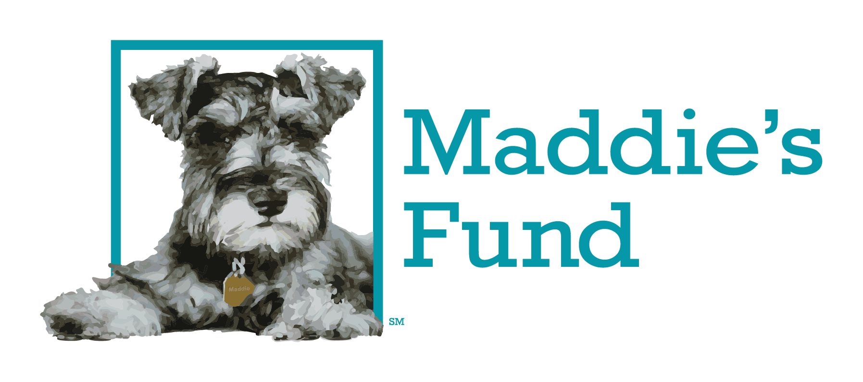

Maddie’s® Shelter Medicine Internship
Shelter Application

Maddie’s Fund® is offering up to $50,000 per year to U.S.-based 501c3 or government animal shelters to train an intern in shelter medicine, in conjunction with a Veterinary College/School. Recipients should have an appreciation of the no-kill philosophy and must honor Maddie’s Fund’s core values of honesty, integrity and mutual respect.

Note: This application is for shelters applying for the grant. If you are a veterinary college/school applying for this grant, please use this application [link].

Please provide the following information:

- Organization Information
  - Name of Organization: _____________________________________________________________________________
  - Head of Organization:
    - Name: _____________________________________________________________________
    - Title:
___________________________________________________________________________
    - Phone: ___________________________________________________________________________
    - Email: ___________________________________________________________________________
  - Organization Address:
    - Street: __________________________________________________________________________
    - City, State, Zip: __________________________________________________________________________
  - Organization Website: _____________________________________________________________________________
  - EIN Number: ____-______________
For questions 1f – 1k, please refer to our Grant Requirements webpage for more information.
  - Please provide the web link to where you are publicly sharing your annual animal statistics on your website (on the same page as your lifesaving percentage - see 1g below). __________________________________________________________________
  - Please provide the web link to where you are publicly sharing your lifesaving percentage, including how it was calculated, on your website (on the same page as your annual animal statistics - see 1f above). __________________________________________________________________
  - To be eligible for a Maddie’s® Shelter Medicine Internship grant, shelters must also have achieved a lifesaving percentage of around 90% or better. What is your lifesaving percentage and how was it calculated: ______________________________________________________
  - My organization is an active participant in Shelter Animals Count.
    - ___Yes
    - ___No, please explain: ___________________________________________________________________________
  - My organization is an active participant in the Million Cat Challenge.
    - ___Yes
    - ___No, please explain: ___________________________________________________________________________
  - My organization is current on all grant reporting requirements for any previous Maddie’s Fund grants. (Please contact Maddie’s Fund at 925.310.5450 if you have questions about this.)
    - ___Yes
    - ___No, please explain: ___________________________________________________________________________

- Organization Demographics:
- Which best describes your organization?
___Municipal animal services
___Animal shelter/rescue with a government contract (i.e., animal control or housing services)
___Shelter without a government contract (physical facility)
___Rescue without a government contract (solely foster-based)
___College/University
___Non-Profit Spay/Neuter Clinic
___Non-Profit Veterinary Clinic
___Other (please specify): ________________________________________________________
- Approximately how many dogs and/or cats does your organization handle annually?
Dogs:
___1 to 99
___100 to 499
___500 to 999
___1,000 to 4,999
___5,000 to 9,999 10,000 or more
___Don’t know
___ (0) Not applicable
Cats:
___1 to 99
___100 to 499 500 to 999
___1,000 to 4,999
___5,000 to 9,999
___10,000 or more
___Don’t know
___ (0) Not applicable

- Application Submitted by Contact Info:
  - ___Same as Head of Organization (skip to #4)
  - ___Different Contact
    - Name: ___________________________________________________________________________
    - Title:
___________________________________________________________________________
    - Phone: ___________________________________________________________________________
    - Email: ___________________________________________________________________________

- Please provide a summary of your model program(s) and any area(s) you’re working to improve:

- Please describe the criteria for how the intern will be selected to receive the Maddie’s® Shelter Medicine Internship:

- Please describe how you plan to educate/train the intern this Maddie’s® Shelter Medicine Internship grant is funding:

- Veterinary College/School you’ll be collaborating with on this Maddie’s® Shelter Medicine Internship:
  - Name of University/College: ____________________________________________________________________________
  - Main Contact at University/College:
    - Name: ___________________________________________________________________________
    - Title:
___________________________________________________________________________
    - Phone: ___________________________________________________________________________
    - Email: ___________________________________________________________________________
    - Street: __________________________________________________________________________
    - City, State, Zip: __________________________________________________________________________
  - Veterinary College’s/School’s Website: _____________________________________________________________________________
  - Veterinary College’s/School’s EIN Number: ____-______________
- Please describe the University’s/College’s shelter medicine program:

- Please provide a budget for this grant:

Any research funded by this grant (either completely or through the Intern’s involvement) must aim to improve the health and well-being of shelter animals and demonstrate direct relevance to adoption guarantee shelter practices and methods. Studies must follow accepted scientific principles so results are credible. No terminal research projects will be accepted, and all studies involving the use of live animals must be approved by the University’s/College’s Animal Care and Use Committee. Any and all publications and presentations arising from the research are required to recognize Maddie’s Fund. Copies of all publications stemming from this project must be submitted to Maddie’s Fund at the time of publication.

If funded, we ask the intern to provide a 6-month update with highlights of what they’ve learned, and for the intern to contribute one piece to the Maddie’s Fund blog, Chew On This. The shelter will be responsible for a final report due within 45 days of the end of the grant funding.

If approved, this program will be named Maddie’s® Shelter Medicine Internship at [your organization name] and the student will have the title of Maddie’s® Shelter Medicine Intern at [your organization name]. Additionally, you will be asked to honor Maddie, the little dog who inspired a movement, through your social media and donor recognition about this grant on your website, donor wall, annual report, newsletter or other promotional materials or marketing communications, as appropriate. And any presentations given or publications written by this intern should recognize Maddie.

Please submit this completed application form to grants@maddiesfund.org.

