Adopting out from home is easy!

If your foster is spayed/neutered, microchipped and vaccinated, they’re good to go!

All the adopter needs to do is:
- Fill out the dog or cat adopter survey (attached)
- Fill out the adoption agreement (attached)
- Pay the adoption fee (Fees vary. If unsure, verify with foster coordinator)
- Pay the $19 licensing fee (dogs only) - cash or check

All you need to do is:
- Hand them the animal’s medical history (included)
- Hand them the animal’s behavior history (included)
- Hand them the Adoption Packet! (included)
- Then you would bring the adopter survey, adoption agreement and adopter fees in to us physically or mail them to:
Pima Animal Care Center
4000 N Silverbell Rd
Tucson, AZ 85745

Just make sure we get the paperwork and fees within a 48 hours of the adoption!

Thank you for being a life-saving foster parent with Pima Animal Care Center!

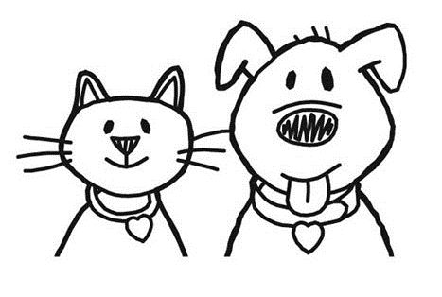

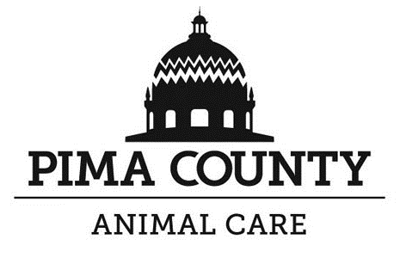

PIMA COUNTY PET ADOPTION AGREEMENT

By adopting a dog/cat and by signing this form, the adopting party agrees to comply with all provisions of this agreement.

If the pet is to be held for spay or neuter surgery, the adopter agrees to reclaim the animal following surgery as directed by the veterinarian. Ownership of adopted animals unclaimed within 12 hours of the arranged pick-up time revert from the adopter back to Pima Animal Care Center

______ I understand that the Pima Animal Care Center cannot and does not make any representations or warranties, either expressed or implied concerning the temperament, habits, health, pedigree, disposition, age, sex or background of this animal and that I have no right to a reimbursement of medical, adoption or other professional fees. Furthermore, I understand that the animal’s future reactions to me, my family or any other person are completely unpredictable because animals, like people, have their own personalities.

______ I understand an animal that appears healthy when adopted may, despite PACC’s best efforts, become ill. The animal I am adopting may or may not be ill at the time I take custody and ownership. I will immediately take my new pet, to my veterinarian, at my expense, if it stops eating, is listless, vomits, has diarrhea, or exhibits other disease symptoms. If I am unable or unwilling to pursue veterinary care at my private veterinarian following adoption, I understand I may return the animal to PACC. If the animal is returned to PACC due to illness or injury, ownership will revert to PACC who will evaluate the animal to determine whether the animal will be provided medical treatment, placement or euthanasia. PACC does not pay any medical expenses for animals it does not own.

______ Pima Animal Care Center reserves the right to conduct premise inspections before and after the adoption of the animal.

______ I assume full responsibility to provide proper food, water, shelter, veterinary care, exercise, and a safe environment for this animal.

______ In consideration of receiving this animal, the adopting party hereby releases Pima County, its officers, agents and employees from all claims of Injury or damage which this dog/cat may cause the adopter or the adopter’s property. The adopting party further agrees to hold harmless, defend and indemnify Pima County, it’s officers, contract veterinarians, agents and employees from any and all claims of liability to other persons for injuries or damage arising out of or in connection with services of this program or caused to them or their property by this dog/cat adopted by the adopting party.

______ If for any reason, the adopting party does not comply with all provisions of this agreement, the adopting party agrees to return the-adopted animal to Pima Animal Care Center upon demand of the enforcement agent.

_______I acknowledge that a staff member has reviewed documented information about this animal with me and that I have received said documentation in writing. I am adopting this animal with awareness of any documented medical or behavioral history.

My signature below attests that I agree to the alteration surgery and have read and understand this agreement.

Adoption Date: ____________________ Signature of Adopter: ________________________________________

Name: _______________________________Phone: ______________________ Phone 2: __________________

Address: ____________________________________________City____________State________Zip__________
Animal's Name: _____________________Animal ID # __________________ Microchip_____________________

